2025

Network Design for my client “HairLux LTD”

YOUCEF LAOUIRA

Contents
ABSTRACT 2
INTRODUCTION 3
AIM AND OBJECTIVES 3
NETWORK DESIGN 4
NETWORK EVALUATION AND DISCUSSION 17
CONCLUSION 17
REFERENCES 18

i

Abstract

The following report highlights the tools and techniques used to implement and deliver the project, consisting of allocating 50 employees between London and Manchester with 40 reliable and accessible networking devices, ensuring security and uninterrupted intercommunication between the two locations.
Different methods have been used for the implementation of this project such as the HSRP protocol to ensure a redundancy link is in place in case of network interruption, as well as the CIDR IP addressing scheme used to allocate each host. The network configuration was implemented with Cisco packet tracer. The project has been subject to rigorous testing to ensure I meet the client expectations.

Introduction

My client, HairLux LTD, a company based in 2022, specialised in luxury hair extensions and other hair products is growing exponentially and is currently seeking to expand their facilities. The client has hired 50 new employees including HR representatives, account managers, data analysts and a dedicated customer service team. The aim of the client is to allocate these employees in two offices based in London and Manchester. Each location can take advantage of two offices to accommodate 10 working stations each, with a total of 40 working devices such as laptops and PCs that can support wired and/or wireless connectivity.
As the leading networking company in our area we, at IntTech24/7, are specialised in delivering networking systems to large scale companies as well as keeping it budget friendly, and no task is difficult enough!
Our responsibility is to deliver, install and configure each device for our client within the preset time limit, while ensuring liability and security. To ensure compliance with requirements I implemented a network with ten laptops and ten PCs for each location, to accommodate wireless connectivity. In the following sections of the report, I will highlight the devices used in the network, every step of the configuration process and the final design of the project.

Aim and Objectives

For this project, the first approach is to lay out all the required devices to implement into the network, followed by the cabling of all PCs, laptops, routers, and switches, finally the configuration of all devices and assess the correct functionality.
The aim is to design an efficient network for HairLux LTD, while considering the costs of the equipment.
The objectives are the following:
- Design the network.
- Implement a CIDR based addressing scheme.
- Use DHCP for dynamic allocation of IP addresses.
- Implement routing protocol for communication between two subnets.
- Implement SSH to allow for remote access login. 6- Create a redundant link with HSRP.

Network Design


The plan
For the design of this network, in both London and Manchester I will be using ten PCs in office 1 that will be connected to a switch for wired connectivity. The switch in this case will be the best option to accommodate the number of devices (10). The switch will simply forward the connection from the main router to the hosts. For office 2, both locations will accommodate 10 laptops each, that will be connected to an access point wirelessly. The access point in this scenario will act as a bridge to allow hosts to be connected wirelessly. Lastly, the two main routers will communicate between each city. Since each location must accommodate at least 20 devices, an appropriate IP addressing scheme must be implemented to accommodate all hosts.


Build the network

-

Office design

This is the design for London office 1, which will accommodate hosts via wired connection, as desired by the client. For this purpose, the below switch is the best option, which can accommodate up to 24 devices via a wired connection.

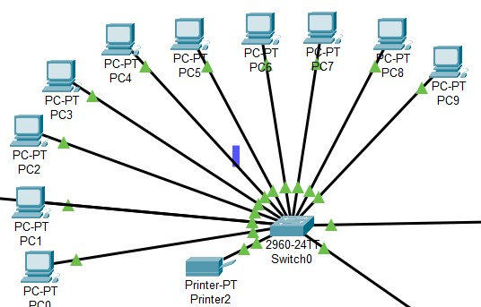

Figure 1: All wired devices connected to a switch.

This is the design for London office 2, which will accommodate hosts via a wired connection, as desired by the client. For this purpose, a basic access point is the best choice.

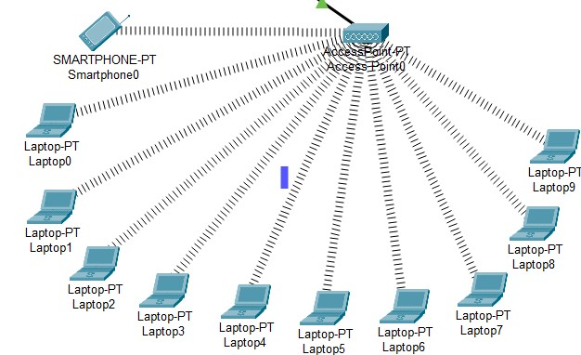

Figure 2: all devices connected wirelessly to an access point.

I repeated the process in both Manchester offices. Lastly a router will be added to each location that will enable communications locally as well as between London and Manchester.
To enable communication between the two locations, I connected the two routers via fiber optic. I identified the best router with the dedicated interface that allows for communication via fiber optic.
This decision will be beneficial over time despite the difference in costs compared to a serial cable.
The benefits of this decision will be further analysed in the evaluation section. The final design of the entire network looks as follows:

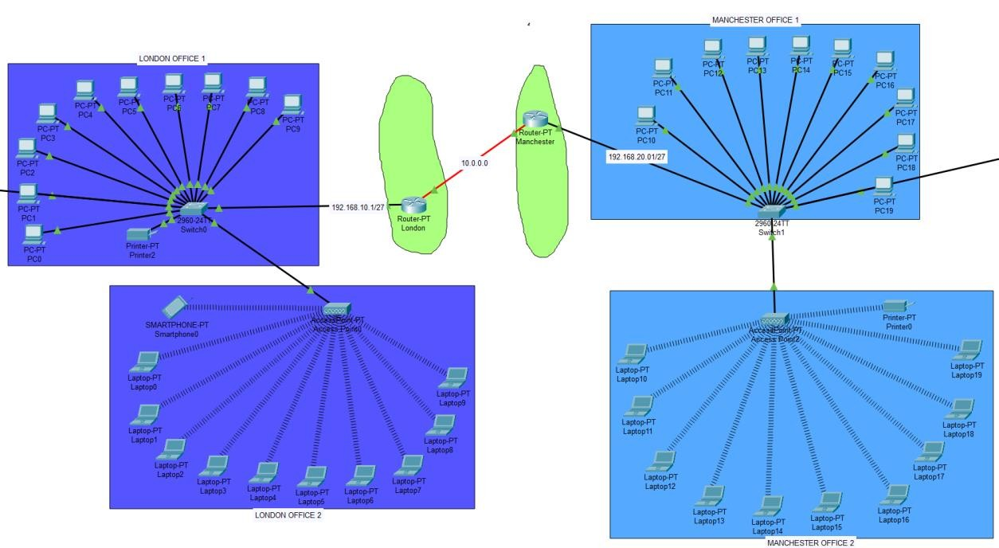
Figure 3: entire network design.


Configure the network

- IP addressing scheme
Now that there is a final network design, is time to think about the approach on assigning IP addresses to each host.
Considering that each location has more or over 20 hosts, as the business may grow, a consideration for additional devices to be added must be made. For this purpose, I opted for the CIDR scheme with /27 subnet mask which will give each location 30 usable IP addresses (IPv4 CIDR Chart, 2015). The subnet mask will be the following: 255.255.255.224. For the offices based in London the assigned subnet is 192.168.10.0, and for the Manchester based offices the assigned subnet is 192.168.20.0.

- DHCP pool
Given the number of devices that need assigning IP addresses, using static IP addresses is not practical. The Dynamic Host Configuration Protocol allows to dynamically assign IP addresses to hosts in a network. This practice allows for devices to be added or removed without the need to access the interested source, in addition, using DHCP for IP configurations rather than a static IP address significantly reduce the risk of a wrong input such as wrong IP address, subnet mask or default gateway (Alcott, 2001, chapter 3).

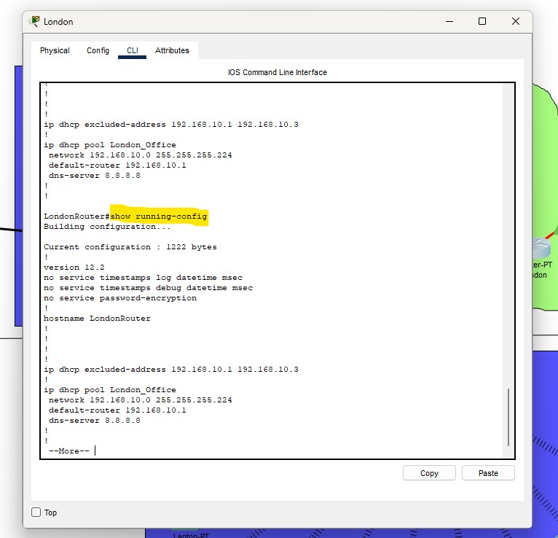

Figure 4: display of DHCP pool after implementation.

As the DHCP pool is created, each host should receive a unique IP address. To check this, on any host device in the desktop tab when choosing IP configuration and toggling DHCP a new IP address should appear.

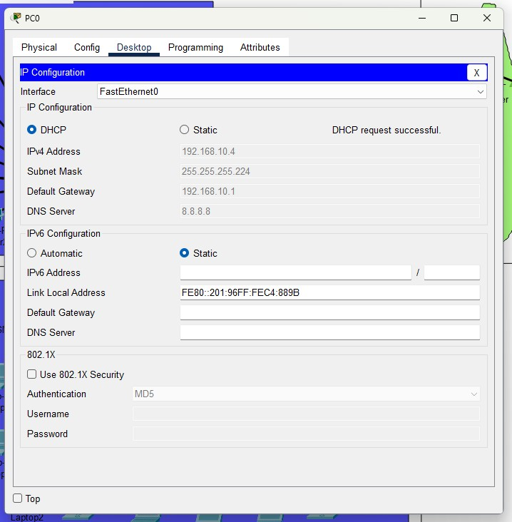
Figure 5: host DHCP request successful.

To ensure London hosts are on the same network and can communicate, ping two devices within the same subnet.
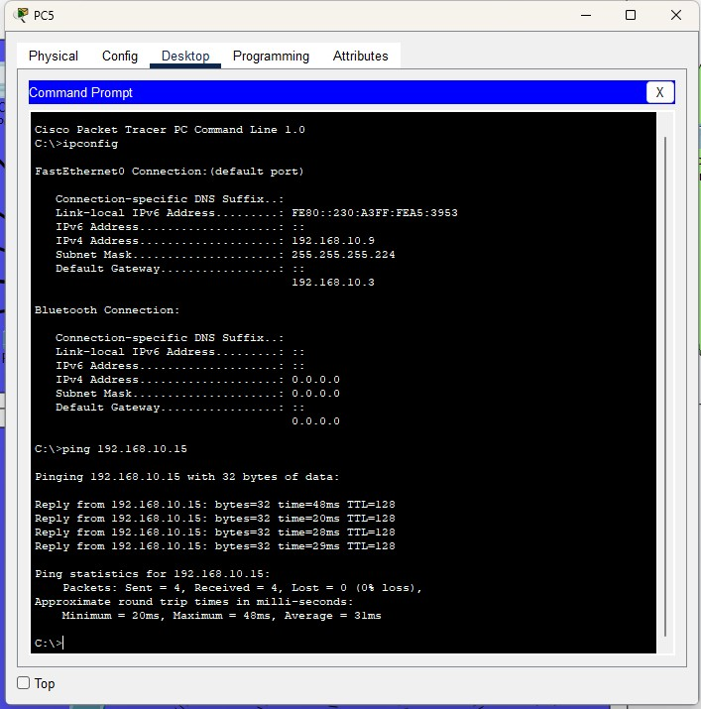

Figure 6: display ipconfig first and the ping command to a host within the same subnet

- RIP configuration

As both locations are now equipped with PCs, laptops, and printers, I implemented a new protocol that allows for uninterrupted communication between London and Manchester. The RIP known as Routing Information Protocol allows the exchange of routing information between routers in a network. It uses a unit measure of hops, uses a version 2 of RIP that allow to multicast updates rather than version 1 where updates are broadcasted. By default, this routing protocol sends updates every 30 seconds (Black, 2000, chapter 5).

The following screenshot shows my implemented RIP protocol to the Manchester router.

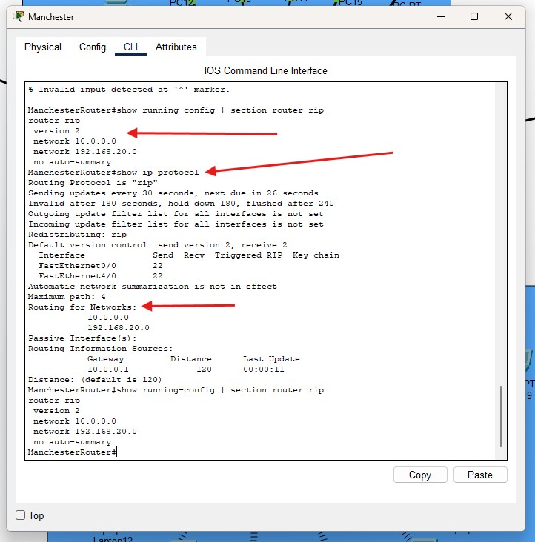
Figure 7: Successful RIP implementation.

The following screenshot proves that the RIP configuration was successful. Ping a device in another subnet. In this case, the subnet 192.168.10.x which is London will ping a device in the subnet 192.168.20.x located in Manchester.

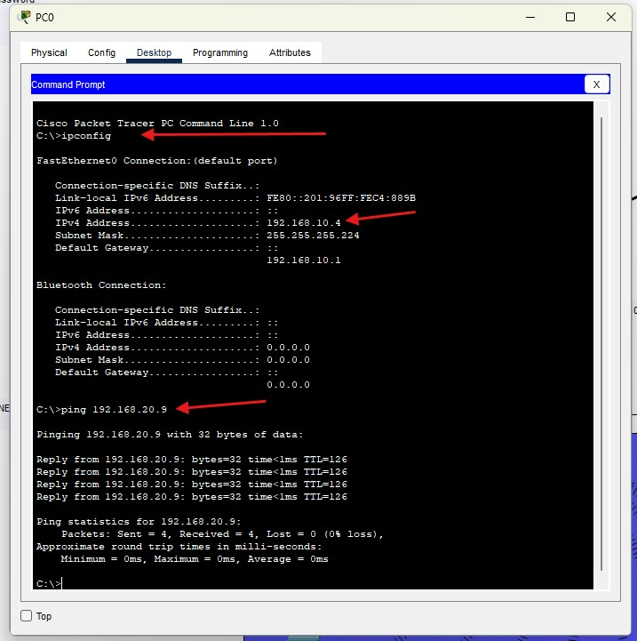

Figure 8: display ipconfig first and the ping command to a host from another subnet.

- SSH configuration
As the network is nearly complete, is time to reinforce the security of the network by implementing safety measures to avoid unwanted attacks in the future.
SSH, known as the Secure Shell, has the duty of encrypting the data while in transit and decrypting it upon reaching the destination. SSH is a software-based network, the end user is connected to an SSH server, in this case the router. End users are provided with login credentials that allow for remote access, and the SSH server will execute their commands (Barret, Byrnes and Silverman, 2005).

The following screenshots will show the implementation of SSH.

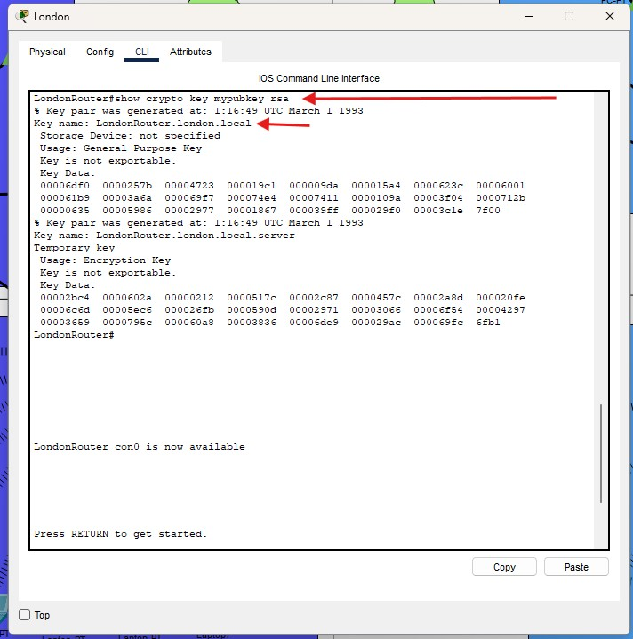

Figure 9: check if the SSH configuration was done correctly with command show crypto key mypubkey rsa.

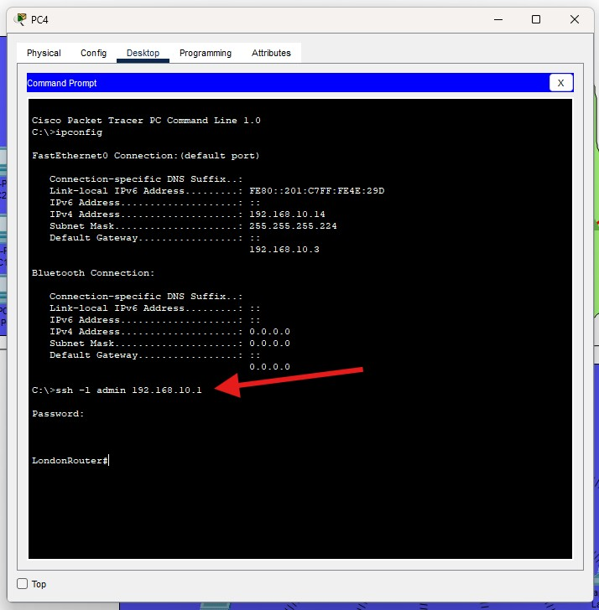
Figure 10: test the SSH configuration and input the correct password

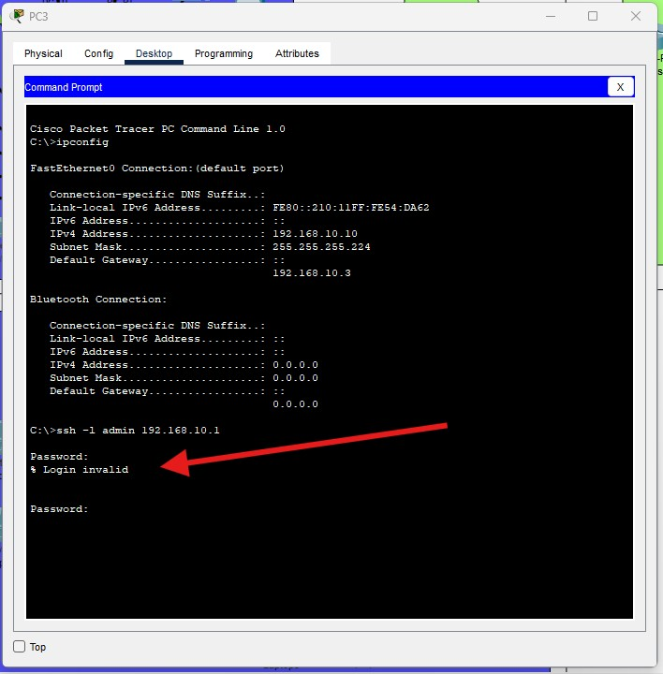
Figure 11: test SSH and input wrong password.

- Redundant link HSRP

As all hosts are configured with workstations ready to use, for the reliability of the network, considerations must be made to maintain a stable network connectivity.
HSRP, known as Hot Standby Router Protocol, is a routing protocol developed by Cisco, it allows an additional router to take over in the case of network failure by the main router. It works with two router that share the same virtual IP address, one router stays active and the other in standby, the virtual IP address will then be the default gateway for all hosts within the subnet (Dooley and Brown, 2006, chapter 22).

To do this I added two additional routers, one for each city, which will be connected to a switch with a copper straight through cable. Below are screenshots of a successful redundant link implemented in both routers in the London office.

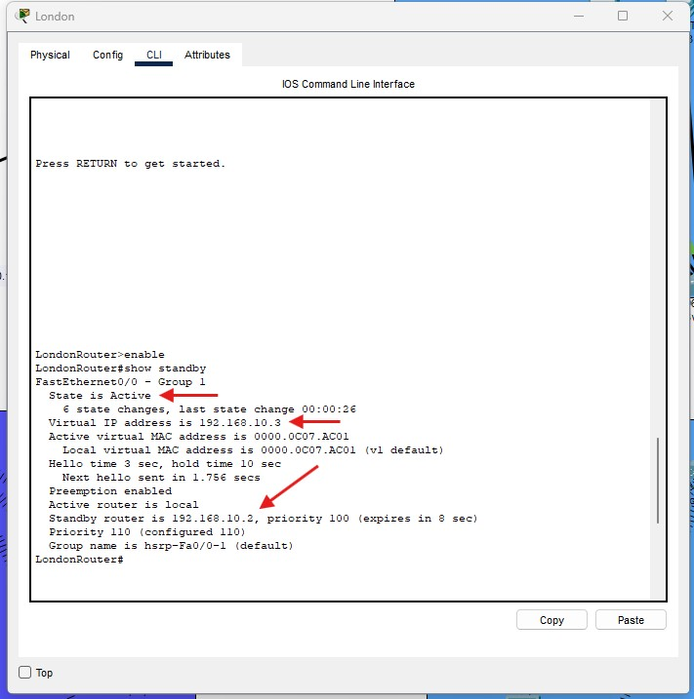
Figure 12: London main router will be the active router.

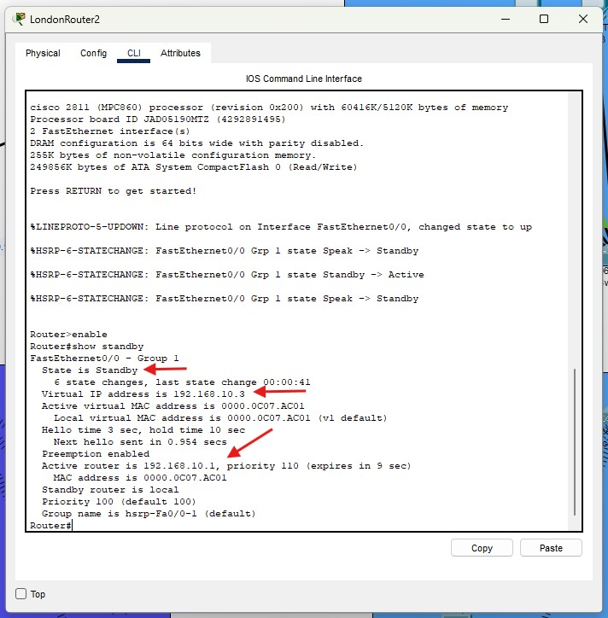
Figure 13: London router 2 will be the router on standby.

Network Evaluation and Discussion

The network design I implemented for my client HairLux LTD considers factors such as redundancy and scalability while maintaining a cost-efficient service.
The current network connects two cities, London and Manchester, with hosts housed in two offices for each location connected via wireless or wired connectivity.

I have addressed network failure with redundancy via the Hot Standby Router Protocol HSRP. A secondary router is added to both cities and in case of a network failure by the main router, the secondary router takes charge. However, the network may be subject to failures in the future as redundancy was not implemented in equipment such as switches or access points, meaning that if one of these fails, hosts connected may lose connectivity.

For this network I used a CIDR based IP addressing scheme to efficiently allocate hosts with IP addresses. I used CIDR notation of /27, subnet mask 255.255.255.224, that gives 30 usable IP addresses. This is sufficient to feed the required number of hosts, 20 per location. However, in the scenario of a sudden growth from the client, could be limiting.
A plan for a larger subnet such as /26 or /25 will support the expansion of the network. A larger subnet may be costly as switches have a limited interface capacity to accommodate additional hosts, a consideration for new switches and access points must be made.

The router connection between the two cities, which uses fiber optic, has played a significant role in terms of balancing costs with efficiency giving the higher initial investment compared to using a serial cable. Fiber optic, while also capable of supporting higher bandwidth than serial cable, can benefit from low maintenance cost given the reliability and speed of the cable. A serial cable, given the distance between the two locations, may require repeaters to maintain a steady connection, this could be costly.

Overall, the design is a success. Is a solid foundation that meets my client requirements, while leaving room for limited scalability. If the network requires expansion is essential to assess whether my client aim is to have a cost saving approach or leverage in redundancy and scalability.

Conclusion

The final network design for my client, HairLux LTD, has addressed the pre-established requirements of the client while also ensuring the efficiency of the network. The two connected locations provide a steady communication system supporting both wireless and wired connectivity.
The design also acknowledges areas of improvement and allows space for enhancements, to accommodate the company future needs.
The implementation of the project was made with strategic decisions to avoid complexity while maintaining a cost-effective service. The project overall has satisfied my client requirements. Finally, this network design has a reliable foundation and offers a path to further enhance the network.

References

Alcott, N. (2001) DHCP for Windows 2000. Available at: https://learning.oreilly.com/library/view/dhcp-for-windows/1565928385/ch03.html#ch03-44370 (Accessed: 15 January 2025).

Barrett, D.J., Byrnes, R.G., Silverman, R.S. (2005) SSH, the secure shell: the definitive guide. Available at: https://learning.oreilly.com/library/view/ssh-the-secure/0596008953/ch01s01.html (Accessed: 15 January 2025).

Black, U. (2000) IP Routing Protocols: RIP, OSPF, BGP, PNNI, and Cisco Routing Protocols. Available at:
https://learning.oreilly.com/library/view/ip-routingprotocols/0130142484/0130142484_ch05lev1sec7.html (Accessed: 15 January 2025).

Dooley, K. and Brown, I.J. (2006) Cisco IOS cookbook. Available at: https://learning.oreilly.com/library/view/cisco-ios-cookbook/0596527225/ch22.html (Accessed: 15 January 2025).

IPv4 CIDR Chart (2015) Available at:
https://www.ripe.net/media/documents/IPv4_CIDR_Chart_2015.pdf (Accessed: 13 January 2025).

